REDCap logo 

COVID Employee Exposure Tracking

**Logging in and getting set up**

1. Go to <https://redcapynh.ynhh.org>

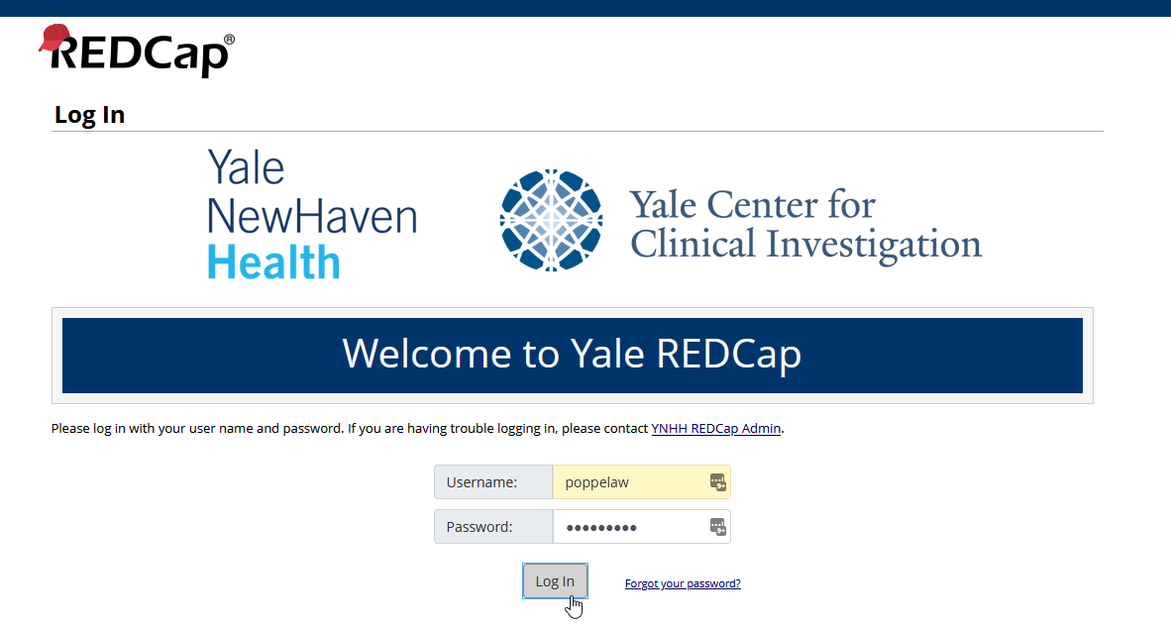

1. Log in with your YNHHS Username and Password (Epic login)
2. Click **My Projects**

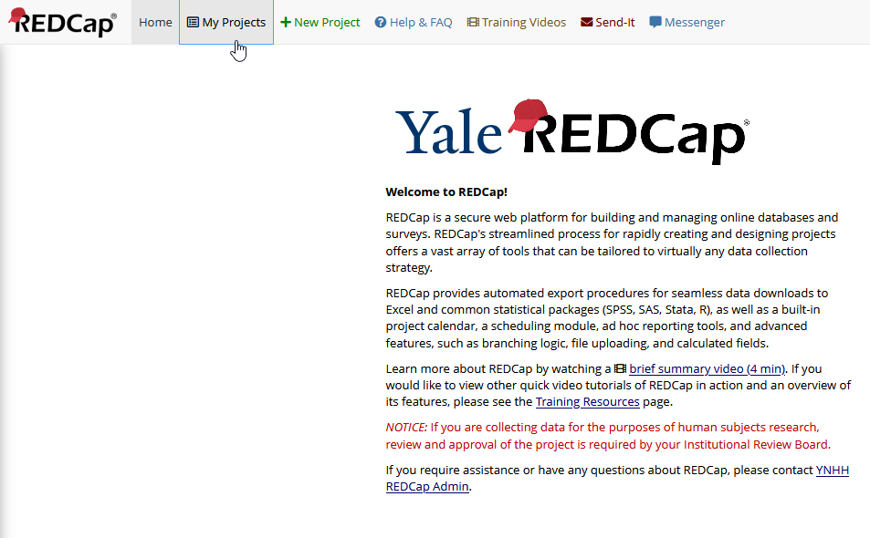

1. Click **COVID Exposure Tracking**

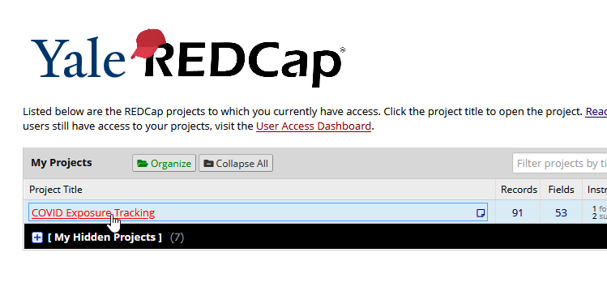

1. The left-side **menu** is a little busy, 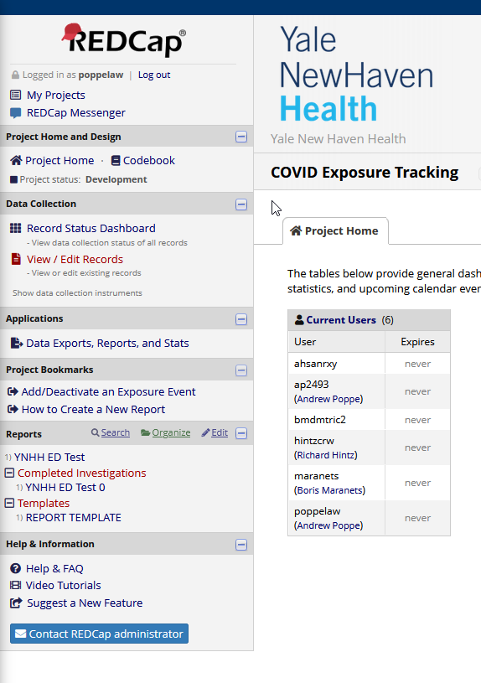

So you can **collapse** some of the sections so that they look like this:

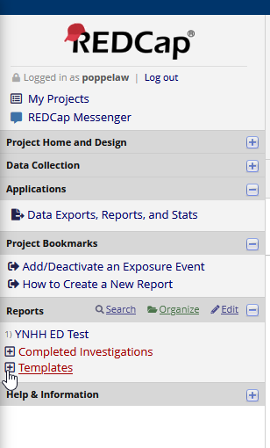

REDCap will remember this layout, so you’re all set up!